Therapeutic Massage & Body Care
1343 Wantagh Avenue
Wantagh, NY 11793
Phone: 516-679-8299
_

RE: Reports and Therapist’s Lien

Patient: ______________________

I do hereby authorize the above Therapist (as per referring Doctor) to furnish, my Attorney, with a full report of his examination, diagnosis, treatment, prognosis, etc. of myself in regard to the accident in which I was involved.

I hereby authorize and direct you, my Attorney, to pay directly to said Therapist such sums as may be due his/her office and to withhold such sums from any settlement, judgement, or verdict as may be necessary to adequately protect said therapist. And I hereby further give a lien on my case to said Therapist against any and all proceeds of any settlement, judgement, or verdict which may have been paid to you, my Attorney or myself as the result of the injuries for which I was been treated or injuries in connection herewith.

I understand that I am directly and fully responsible to said Therapist for all medical bills submitted by him/her for service rendered me and that this agreement is solely made for the Therapist’s additional protection and in consideration of him/her awaiting payment. And I further understand that such payments are not contingent on any settlement, judgment or verdict by which he/she may eventually recover said fee.

DATE: ________________ Patient’s Signature: _________________________

This undersigned being Attorneys of record for the aforementioned patient does hereby agree to observe all the terms of the above and agrees to withhold such sums from any settlement, judgement or verdict as may be necessary to adequately protect said Therapist above named.

DATE: ________________ Attorney’s Signature: ________________________

Attorney: Please date, sign and return to Therapist’s office at once.
Reply envelopes attached. Keep one copy for your records.

No Fault/Workers Comp

Patient Information

Patient Name: ________________________ SS#___________________________

Address: ___________________________________________________________

DOB: _________________________ Phone#_________________________

Insured Name: ________________________SS#___________________________

Insurance Information

Worker’s Comp: ______________________ Phone#________________________

No Fault Insurance: ____________________Phone#_________________________

Address: ____________________________________________________________

Claim#: _____________________________ Policy #: ________________________

Date of Accident: _____________________ Rx: ____________________________

Doctor Name: ________________________ Phone#: _________________________

Are you seeing any PT, Chiro, or other LMT? _____________________________

Adjuster’s Name: _____________________ Phone #_______________________

Check List (Front Desk Staff)

Prescription: Yes___________No____________________
Receiving Doctor: ___________________________________
Verified – Date: _______________By___________________
Spoke To: _________________________________________
Claim Open/Can Submit Bills_________________________
Address To Send Bills_______________________________
Can Have Concurrent Treatment: Yes_________No________

1343 Wantagh Avenue
Wantagh, NY 11793
(516) 679-8299

Confidential Information
Welcome. We want to make your visit as pleasant and comfortable as possible.
If at any time you have any questions or concerns, please let us know.

Name: __________________________________________________________ D.O.B. __________________________
Phone Number #: ___________________ Email: _______________________________
Would you like to receive texts: Y / N Emails: Y / N about upcoming appointments?
If you would like to receive text messages, what cellphone carrier do you use? __________________________________
Street Address_____________________________________________________________________________________
City __________________________________ State __________________________ Zip Code ____________________
Have you received massage therapy before? Y / N - If so what type? Deep tissue? Y / N Swedish? Y / N Other? Y / N
What medication do you take? ________________________________________________________________________
Have you consumed alcohol in the past 24 hours? Y / N
Emergency Contact Name: ________________________ Phone #: __________________ Relationship: ______________
Referred By: ____________________
Do you have a history of any of the following? Please Check
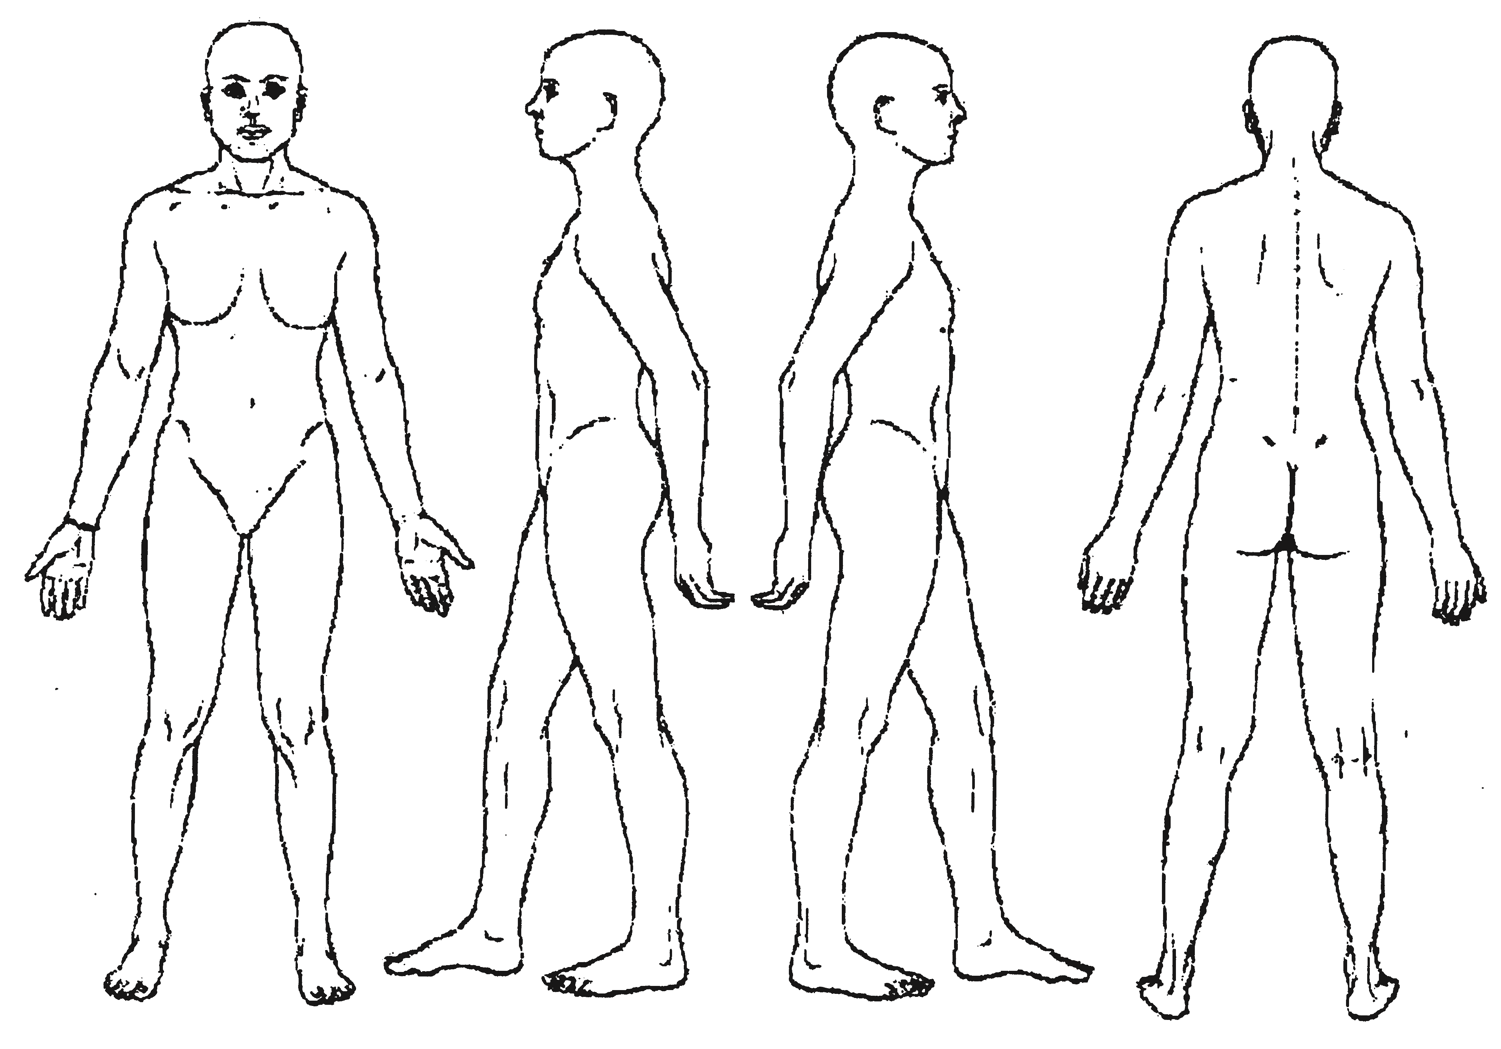
Please Mark Area(s) of Pain
Accidents | Disk Problems | Joint Aches
Headaches | Lower Back Pain | Abdominal Pain
High Blood Pressure | Cancer | Diabetes
Allergies to oils/  perfumes | Wear contacts or other  prosthesis | Decreased Range of  Motion
Stroke | Colitis | Whiplash
Varicose Veins | Heart Attack | Mid Back Pain
Surgery | Seizures | Arthritis, bursitis, gout
Broken Bones | Nervous Tension | Breast augmentation
Neck Pain | Sprains | HIV
Fibromyalgia | T.M.J. | Other
Do you have any of the following today?
Sunburn | Inflammation
Severe Pain | Headache
Open Cuts, bruises, burns | Irritated Skin Rash
Poison Ivy | Cold/Flu
Is there anything else that we should know?
________________________________________________
________________________________________________
________________________________________________

I understand this massage is not a replacement for medical care and that no diagnosis will be made. I am responsible for paying for any appointment cancellation of less than 24 hour. If this office is submitting paperwork to my insurance carrier, I authorize the release of any medical or other information necessary to process an insurance claim. I authorize payment of medical benefits to the Licensed Massage Therapist or office listed above, for services tendered.

Signature Date

